**Final Report**

On

**FITBEE**



*For*

*the partial fulfillment for the requirement*

*of the degree*

*of*

**“BACHELOR OF COMPUTER APPLICATIONS”**

(BCA 6TH Sem)



**Guru Nanak Dev University**

**AMRITSAR**

**Submitted to: Submitted by:**

Miss.Krishma Sukhdeep kaur

(Prof. In Comp.Dept.) **R.no.:-**10721912505

**Table of Contents**

|  |  |  |
| --- | --- | --- |
| **Sr. No.** | **Topic** | **Page No.** |
| 1. | Introduction | 1-2 |
| 2. | Hardware and Software  Requirements | 3 |
| 3. | Frontend | 4 |
| 4. | Backend | 5-6 |
| 5. | SDLC Model | 7-9 |
| 6. | Data flow Diagram | 10 |
| 7. | ER Diagram | 11-12 |
| 8. | Data Table | 13 |
| 9. | forms | 14-17 |
| 10. | Bibliography/References | 18 |
| 11. | Conclusion | 18 |

**INTRODUCTION TO PROJECT**

**FITBEE –**

FITBEE is a PHP and MYSQL project based on fitness. This is a web-based project and it has been developed using PHP and MYSQL.

We all know that Fitness is essential for a healthy and tension free life. Being healthy is the first priority despite of the apartment, car or any degree. Fitness includes the diet, exercise and sleep. These three things have their own importance in each individual’s life and it is sensible with regard to those for a healthy life.

**OBJECTIVE OF PROJECT-**

Being healthy is the first thing to be kept in mind because most of the time our attitude depends on how we feel. Being healthy gives us the energy to work and do things. But, this is hard to get admission in health clubs due to hectic professional life. Therefore, the aim of this project is to automate the gym and fitness process. So that, one can get the fitness tips at their own comfort.

**SCOPE OF PROJECT: -**

As the technology and the passion of being muscular and healthy is increasing day by day. So, the need for a well-organized, computer base gymnasium Fitness System has become the need of society.

This system helps the Owner and Admin to maintain large data about users and their daily activities like workout, diet plans etc. Also, suitable for users for creating automated online profile as they do not need to go anywhere. Our Fitbee System is the best option for it.

**MODULES OF FITBEE :-**

* Diet plans – Diet plans for weight loss or weight gain.
* Workout – Training modules with fitness tips.
* Health Tools – Calculators to calculate the BMI and BMR.
* Blogs – Various articles for fitness
* Recipe guide – Various recipes and food nutrition information for healthy diet plan
* News – News about health or about current situation (i.e. Corona virus)
* User module **–** User’s login information
* Admin module – Admin can manage the users, edit/delete the various categories (like articles, blogs, workout exercises, diet plans etc.)

**INTERFACES OF PROJECT:-**

There are two interfaces in this project-

* Admin
* User

**TECHNOLOGIES USED IN THE PROJECT :-**

* + **HTML:-**Used for page layout designing.
  + **CSS:-** Used for all the designing part.
  + **JAVASCRIPT:-**Used for all the validation task and animation.
  + **PHP:-** Used for frontend.
  + **MYSQL:-**Used as database for the project.
  + **APACHE2:-**Project will be run over this server.
  + **SERVER:-** XAMP,UWAMP,LAMP.

**ADVANTAGES:-**

* All in one health tool.
* Monitor your diet easily.
* Get free health and fitness tips at own comfort.
* Admin can update the system or manages the information about fitness.
* Admin can track all the information about users.

**DISADVANTAGES:-**

* Lack of human interaction.
* Internet connectivity is must require for some modules.

**Hardware & Software Requirements**

* **Hardware requirements server**

1. Inter(R) core(TM)2 cpu

2. 1.00 GB Ram

4. Optical drive

5. Keyboard and mouse

6. Internet Connection

* **Software requirements of Server**

1. Server based operating system

2. Apache HTTP Server 2.4.6

3. PHP 5.x

4. Ajax Support

* **Hardware requirements of Client**

1. Any PC processor

2. 512 MB Ram

3. Keyboard mouse

4. Internet Connection

* **Software Requirements Client**
* Any operating system
* Web Browser

**FRONT END**

**Introduction to PHP**

**PHP**

PHP is a server scripting language, and is a powerful tool for making dynamic and interactive Web pages quickly. PHP is a widely-used, free, and efficient alternative to competitors such as Microsoft's ASP.

Before you continue you should have a basic understanding of the following:

* HTML
* CSS
* JavaScript

**What is PHP?**

* PHP is an acronym for "PHP Hypertext Preprocessor".
* PHP is a widely-used, open source scripting language.
* PHP scripts are executed on the server.
* PHP costs nothing, it is free to download and use.

## Why PHP?

* PHP runs on various platforms (Windows, Linux, UNIX, Mac OS X, etc.)
* PHP is compatible with almost all servers used today (Apache, IIS, etc.)
* PHP supports a wide range of databases
* PHP is free. Download it from the official PHP resource: [www.php.net](http://www.php.net/#_blank)
* PHP is easy to learn and runs efficiently on the server side.

**Syntax-**

<? php

echo '………';

?>

**BACKEND**

**INTRODUCTION TO MYSQL**

**MySQL**

* MySQL is the most popular database system used with PHP.
* MySQL is a database system used on the web.
* MySQL is a database system that runs on a server.
* MySQL is ideal for both small and large applications.
* MySQL is very fast, reliable, and easy to use.
* MySQL supports standard SQL.
* MySQL compiles on a number of platforms.
* MySQL is free to download and use.
* MySQL is developed, distributed, and supported by Oracle Corporation.

MySQL is named after co-founder Monty Widenius's daughter: My

The data in MySQL is stored in tables. A table is a collection of related data, and it consists of columns and rows. Databases are useful when storing information categorically. A company may have a database with the following tables:

* Employees
* Products
* Customers
* Orders

PHP combined with MySQL are cross-platform (you can develop in Windows and serve on a Unix platform).

Use the PHP mysqli_connect() function to open a new connection to the MySQL server.

**Open a Connection to the MySQL Server**

Before we can access data in a database, we must open a connection to the MySQL server.

In PHP, this is done with the mysqli_connect() function.

**Syntax:**

mysqli_connect (host, username, password, dbname );

**Close a Connection**

The connection will be closed automatically when the script ends. To close the connection before, use the mysqli_close() function:

**EXAMPLE:-**

*<?php*

*$con=mysqli_connect("example.com","peter","abc123","my_db");*

*// Check connection*

*if (mysqli_connect_errno($con))*

*{*

*echo "Failed to connect to MySQL: " . mysqli_connect_error();*

*}*

*mysqli_close($con);*

*?>*

**SYSTEM DEVELOPMENT LIFE CYCLE**

**INTRODUCTION TO SDLC:-**

System development means developing information system solution to business problem of an organization. System analyst works with the user and identifies goals and builds the system to achieve them. When the system approach is applied to the development of information system solution, a multi step cycle emerges, which is SDLC.

System development life cycle is a cyclic process in which information conceived designed and implemented for fulfilling the need of end user. System development consists of two major steps (i.e.) system analysis and design. Besides this, it involves several distinct phases, 7 users carry out to develop and implement an information system. It is not procedure that deals with hardware and software, rather, it is a building a computer-based system to help the user operate a business or make decisions effectively and manage an enterprise successfully.

SDLC is an organized way to build an information system. It involves development of candidate system i.e. A newly developed system to replace currently existing system. For better working, the task of designing a system is divided into a series of phases.

**PHASES OF SDLC:-**

There are many phases in development of an information system, which constitute the system life cycle. In this we will discuss only following phases:

* Feasibility Study
* Requirements gathering and analysis
* Design
* Implementation / coding
* Testing
* Installation/deployment
* Maintenance

ORGANISATION

TOPMANAGEMENT

USER

SYSTEM ANALYST

GOVT. RULES &

REGULATIONS

CONSUMERS

UNION

COMPETITION

Implies for Change

NEEDS ANALYSIS

FEASIBILITY STUDY

SYSTEM ANLYSIS

SYSTEM DESIGN

DEVELOPMENT

IMPLEMENTATION

SYSTEM EVALUATION

SYSTEM MAINTENANCE

Fig. SDLC Model

**1.** **FEASIBILITY STUDY:-**A feasibility study is a test of a system proposal according to its work ability, impact on the organization ability to meet user needs and effective use of resources. The feasibility study problem has the following have the following types:

* **Technical feasibility -** Whether the problem be solved using existing technology and resources available?
* **Economic feasibility -** The likely benefits outweigh the cost of solving the problem which is generally demonstrated by a cost/ benefit analysis.
* **Operational feasibility -** Whether the problem can be solved in the user’s environment with existing and proposed system workings?
* **Organizational feasibility –** Whether the proposed system is consistent with the organization’s strategic objectives?

**2. REQUIREMENTS GATHERING & ANALYSIS:-** This phase refers to the Planning for the [quality assurance](https://www.guru99.com/all-about-quality-assurance.html) requirements and recognization of the risks involved is also done at this stage. This stage gives a clearer picture of the scope of the entire project and the anticipated issues, opportunities, and directives which triggered the project. Requirements Gathering stage need teams to get detailed and precise requirements. This helps companies to finalize the necessary timeline to finish the work of that system.

**3. DESIGN:-** In this phase the system and software design is prepared from the requirement specifications which were studied in the first phase. System Design helps in specifying hardware and system requirements and also helps in defining overall system architecture. The system design specifications serve as input for the next phase of the model.

**4. IMPLEMENTATION / CODING:-**On receiving system design documents, the work is divided in modules/units and actual coding is started. Since, in this phase the code is produced so it is the main focus for the developer. This is the longest phase of the software development life cycle.

**5. TESTING:-**After the code is developed it is tested against the requirements to make sure that the product is actually solving the needs addressed and gathered during the requirements phase. During this phase unit testing, integration testing, system testing, acceptance testing are done.

### **6. Installation/Deployment:-**Once the software testing phase is over and no bugs or errors left in the system then the final deployment process starts. Based on the feedback given by the project manager, the final software is released and checked for deployment issues if any.

**7. MAINTENENCE:-**Once the system is deployed, and customers start using the developed system, following 3 activities occur

* Bug fixing – bugs are reported because of some scenarios which are not tested at all
* Upgrade – Upgrading the application to the newer versions of the Software
* Enhancement – Adding some new features into the existing software

**Data Flow Diagram**

User

Admin

Database

**change password**

**Admin/User**

**Admin/User**

**Pass changed successfully**

**Old Pass does not match**

**ER DIAGRAMS:**

DIET

PLANS

TRACKING

USER

CHANGE PASSWORD

CHANGE PASSWORD

ADMIN

EXERCISE

USER

VIEW/FETCH INFORMATION

DIET PLANS

EXERCISE PLANS

CALCULATE

**DATA TABLES**

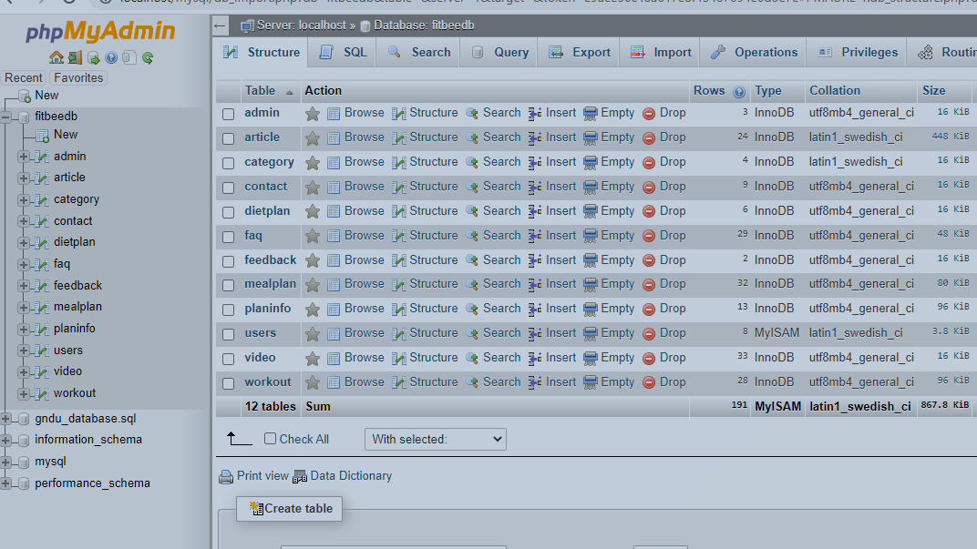

**FORMS**

**HOME PAGE –**

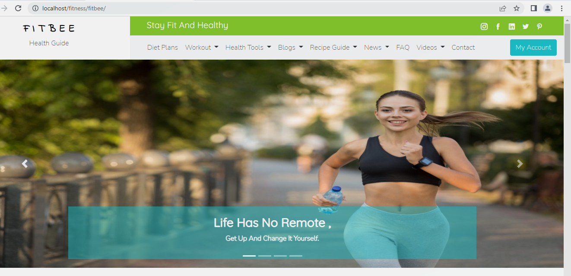

**USER PAGE AFTER LOGIN –**

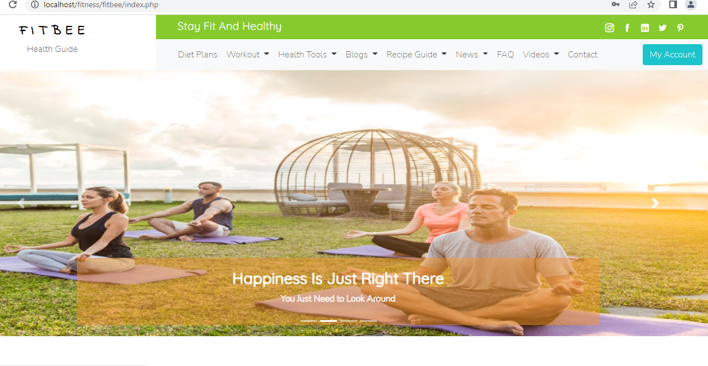

**DIET PLANS PAGE –**

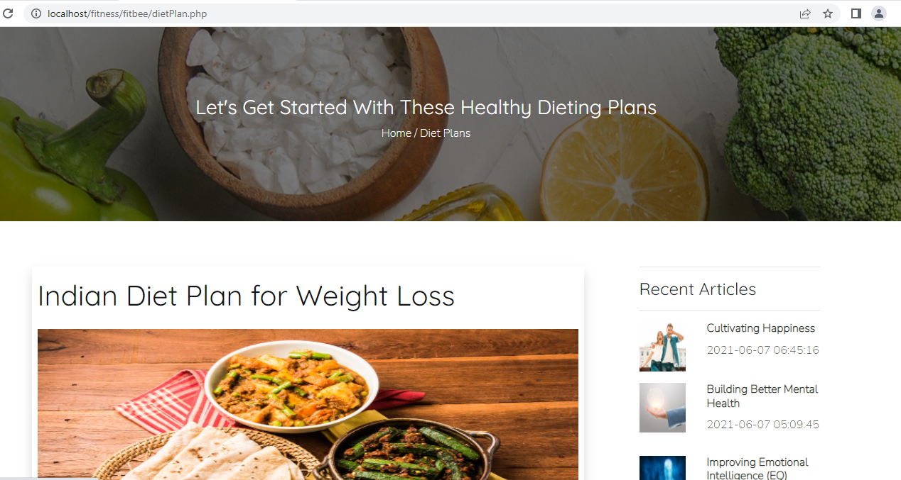

**FITNESS TIPS PAGE –**

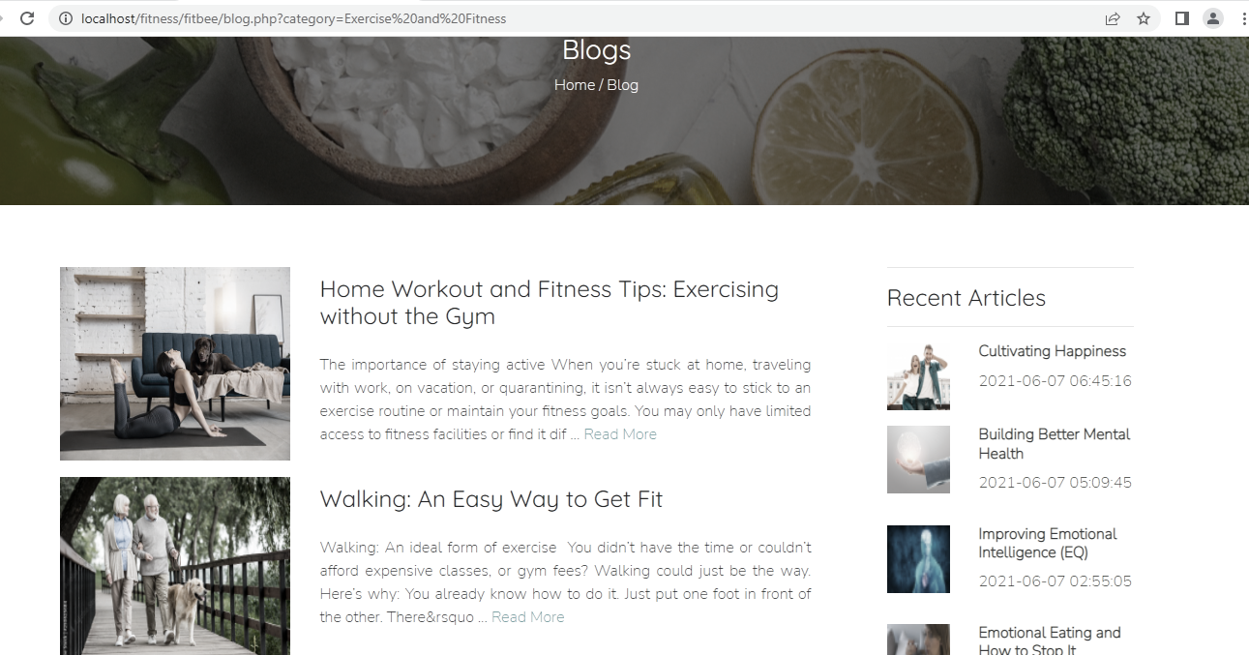

**HEALTH TOOLS –**

* **BMI**

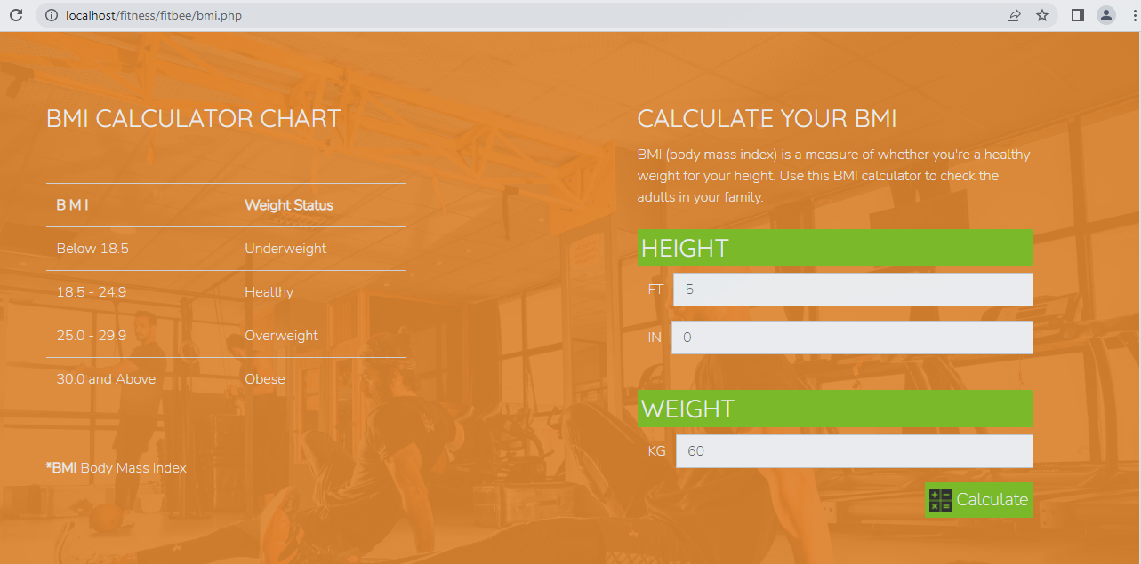

* **BMR**

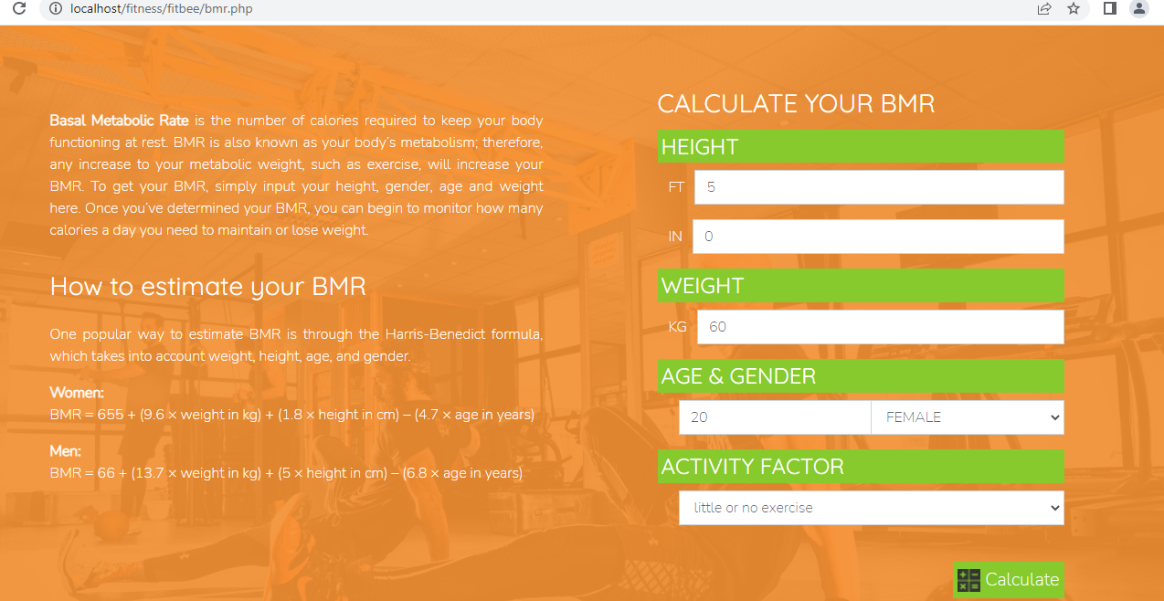

**ADMIN PAGE –**

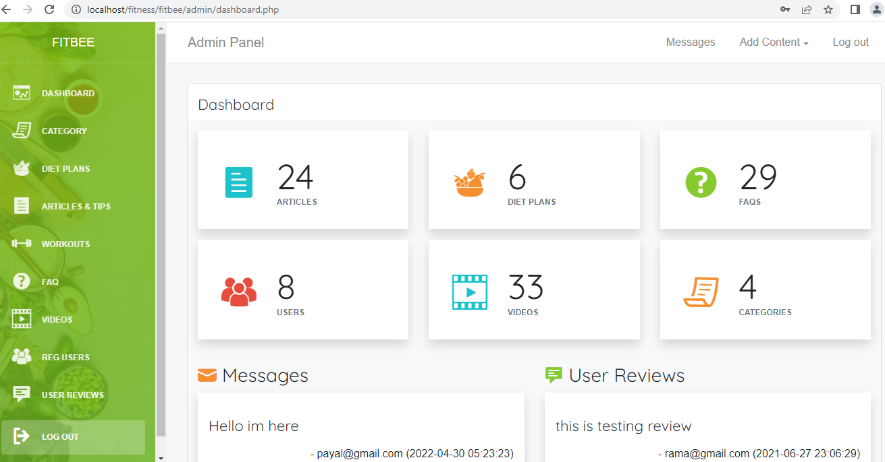

**Bibliography/References:-**

* Google for problem solving
* [www.javapoint.com](http://www.javapoint.com)
* [www.scribd.com](http://www.scribd.com)

**CONCLUSION: -**

To conclude this, we can say that this project will be beneficial for those who want healthy lifestyle. As such people can get guidance about their health, diet plans or what type of exercises required for them just with one click while staying at home or with professional life too.